**Building a Centralized IoT Hub using master device (Raspberry Pi)**

Author: Ankit Meena 1, Ananya Tripathi 2, Arsh Malik 3, Anup Kumar Tewary4, Bhukya Arun Kumar 5

**Abstract**

In the ever-evolving landscape of the Internet of Things (IoT), the need for efficient and centralized device management is paramount. This research paper presents a novel approach to establishing a centralized IoT hub utilizing the formidable capabilities of the Raspberry Pi as the master device. In this system, Raspberry Pi orchestrates and manages various IoT devices, predominantly ESP32-based slave devices and other smart devices, to a cohesive and interconnected ecosystem. Our study explores the implementation, and functionalities of this centralized IoT hub. We delve into the intricate details of how the Raspberry Pi assumes the role of the master device, enabling seamless communication and control over the connected IoT devices. Additionally, we elucidate the protocols, interfaces, and software components that facilitate this communication. The Raspberry Pi can be connected to the display/ monitor to use it as a personal computer, the monitor can be also used as smart tv. Raspberry Pi can control all the devices simultaneously performing all the task at the same time. By centralizing control, the Raspberry Pi can enforce access control policies for different IoT devices. This means that only authorized users or devices can access and control specific devices within the ecosystem. Unauthorized access attempts can be detected and prevented; this enhances the security of all the devices. Furthermore, we discuss the practical applications and advantages of our system, highlighting its potential to streamline home automation, industrial control, and various IoT-driven scenarios. We also present experimental results demonstrating the system's efficiency, reliability, and scalability, showcasing its potential for broader adoption in IoT environments.

**Introduction**

The Internet of Things (IoT) has emerged as a transformative force, connecting a multitude of devices and systems to enable a smarter and more efficient world. In this ever-expanding IoT landscape, the management and coordination of

Ankit Meena

[ankitjarwalll@gmail.com1](mailto:ankitjarwalll@gmail.com1),

Ananya Tripathi

[trips.ananya3@gmail.com2](mailto:trips.ananya3@gmail.com2),

Arsh Malik

[malikabhi1289@gmail.com3](mailto:malikabhi1289@gmail.com3),

Anup Tewary

[anuptewary549@gmail.com4](mailto:anuptewary549@gmail.com4),

Bhukya Arun Kumar

[arun.16518@lpu.co.in](mailto:arun.16518@lpu.co.in)5

School of Computer Application, Lovely Professional University 1234

School of Electronics and Electrical Engineering, Lovely Professional University 5

diverse devices are pivotal to achieving seamless automation and control. While numerous IoT solutions exist, there remains a pressing need for an efficient and centralized hub capable of harmonizing disparate devices into a unified ecosystem.

This research paper addresses this need by introducing a groundbreaking approach to IoT device management, centred around the remarkable capabilities of the Raspberry Pi as the master device. In a world where IoT encompasses everything from smart thermostats to industrial sensors, the ability to efficiently control and communicate with a diverse range of devices is paramount.

Our study embarks on a journey through the architecture, implementation, and functionalities of this centralized IoT hub, highlighting the Raspberry Pi pivotal role in orchestrating and managing various IoT devices. The Raspberry Pi assumes the mantle of a master device, enabling seamless communication and control over the connected IoT peripherals. Moreover, we elucidate the protocols, interfaces, and software components that underpin this interconnected web of devices. Beyond its role as an IoT master device, it can also be connected to a display or monitor, effectively transforming into a personal computer or even a smart TV. This unique feature amplifies the Raspberry Pi utility, allowing it to perform a multitude of tasks concurrently.

Furthermore, this paper explores the practical applications and advantages of our system, emphasizing its potential to streamline home automation, enhance industrial control processes, and adapt to a myriad of IoT-driven scenarios. Through a series of experiments, we unveil the efficiency, reliability, and scalability of our solution, showcasing its readiness for broader adoption in diverse IoT environments. To essence, this research contributes significantly to the evolution of IoT technologies. By presenting a robust and adaptable solution for centralized device management, it underscores the influential role of the Raspberry Pi as a master device, poised to shape the future landscape of IoT ecosystems. In a world where interconnectedness is key, our approach stands as a promising step toward a smarter, more seamlessly integrated future.

**Literature Review**

There are multiple research projects being done using Rpi. In earlier research done by other researchers is following:

|  |  |  |  |  |
| --- | --- | --- | --- | --- |
| **Paper Title** | **Authors Name** | **Year** | **Methodology** | **Limitations** |
| A smart TV viewing and Web access interface based on video indexing techniques.  [IEEE Link](https://ieeexplore.ieee.org/document/1013993) | Kuwano, H., Taniguchi, Y., Minami, K., Morimoto, M., & Kojima, H by. (n.d.). | 2002 | The functionality of this project, Joy TV, is to enhance the TV viewing experience by automatically detecting scene changes, music, and superimposed texts in live TV broadcasts in real time. It then uses these indexes to enable users to browse and retrieve TV content more efficiently. Additionally, Joy TV offers a novel method for web access through TV, linking TV content to web pages using image features, all without the need for manually created electronic program guides (EPG). | It faces accuracy, compatibility, resource, and privacy challenges. Superimposed text recognition and web linking effectiveness vary. |
| Memory Access Scheduling for a Smart TV.  [IEEE Link](https://ieeexplore.ieee.org/document/7005479) |  | 2016 | The functionality of this project is to design a specialized memory access scheduler tailored for the demanding computational and memory requirements of smart TV System-on-Chip (SoC) devices. This scheduler optimizes memory utilization for various real-time graphics and user-responsive tasks, ensuring high memory throughput and priority handling, even under heavy memory traffic conditions. Through innovative future prediction and priority management techniques, the project significantly enhances memory performance, achieving up to 98% of the ideal upper bound throughput for smart TVs. | It faces challenges in scenarios with exceptionally intense memory traffic or unforeseen system demands. |
| Smart TV interaction system using face and hand gesture recognition.  [IEEE Link](https://ieeexplore.ieee.org/document/6486845) | Sang-Heon Lee, Myoung-Kyu Sohn, Dong-Ju Kim, Byungmin Kim, & Hyunduk Kim | 2013 | The functionality of this project is to create a system for smart TV interaction by recognizing human faces and natural hand gestures. It enables viewer authentication through face recognition and control of smart TV functions, such as adjusting volume and changing channels, through hand gesture recognition. Additionally, the system allows for personalized services like recommending favourite channels or providing parental guidance based on face recognition. The project demonstrates high accuracy in both face and hand gesture recognition, making it effective for enhancing the smart TV user experience. | The limitations include distance sensitivity, lighting variations, potential false detections, and privacy concerns with face recognition for viewer authentication. |
| When Smart Devices Are Stupid: Negative Experiences Using Home Smart Devices  [IEEE Link](https://ieeexplore.ieee.org/document/8844630) | Weijia He; Jesse Martinez; Roshni Padhi; Lefan Zhang | 2019 | The functionality of this project is to investigate and understand the negative experiences that users encounter with household smart devices, including issues related to power outages, network failures, false alarms, and user programming concerns. Through an online survey-based study, the project aims to identify these challenges and proposes a research agenda focused on enhancing the transparency and usability of smart devices to provide a safer and more user-friendly experience for device owners. | Limitations include a small sample size, self-reported data, potential response bias, and specificity to certain devices and demographics. |
| SEED smart pixel devices  [IEEE Link](https://ieeexplore.ieee.org/document/379365) | Lentine, A. L. (n.d.) | 1993 | The functionality of this project revolves around the development and utilization of optoelectronic processing devices known as "smart pixels." These smart pixels, particularly the quantum well self electro-optic device (SEED), are designed to perform a range of advanced functions beyond basic logic gates. They integrate quantum wells within p-i-n diode structures to enable both light detection and modulation. These devices, including transistor-diode SEEDs like the field effect transistor SEED (FET-SEED), aim to enhance functionality, reduce optical energy requirements, and achieve complex digital and analogy operations, thereby advancing optoelectronic processing capabilities | Limitations include complexity, sensitivity, compatibility, energy consumption, integration challenges, speed constraints, cost, and limited commercial availability. |
| Smart pixel devices and free-space digital optics applications  [IEEE Link](https://ieeexplore.ieee.org/document/484697) | A.A. Sawchuk | 1995 | The functionality of this project involves the integration of optics and electronics in Free-Space Digital Optics (FSDO) systems. These systems use smart pixel nodes with optical detectors and modulators to create high-capacity, parallel interconnections. They employ fixed optical components to establish intricate 3-D interconnection topologies, enhancing data bandwidth, spatial density, and information spatial channel density. FSDO is especially effective for applications requiring high data capacity, spatial channel density, and parallel data transfer, such as communication switching, photonic space switching, parallel computing, and optical neural systems. | Challenges include complex integration, varying error correction efficiency, compatibility with data formats, size constraints, cost considerations, scalability issues, and potential real-world interference. |
| A Responsive Web Design Approach to Enhancing the User Web Browsing Experience on Smart TVs  [IEEE Link](https://ieeexplore.ieee.org/document/7994709) | Perakakis, E., & Ghinea. |  | The functionality of this project is to enhance the user experience of viewing websites on smart TV devices by implementing responsive web design techniques. This approach aims to optimize website layouts and interactions for larger screens, improving usability and task completion times without the need for creating separate TV-specific websites or apps. | It encounters issues with browser support, remote control input, and performance. Content adaptation, standardization, testing, and accessibility are crucial for an effective TV-responsive website. |

Objectives is to achieve and Build a Centralized IoT Hub using master device Raspberry Pi with the multiple sensors to get more and accurate insights of the given condition. In conclusion, these research papers have given a brief idea of the different sensors and how sensors are used to maximise their potential. This will also help in home automation and also a practical and user-friendly approach to make home automation and industry automation. It effectively combines advanced technology with IoT capabilities to provide a reliable solution.

**Methodology of building a centralized IOT hub using master device Rpi:**

The working of centralized IOT hub using master device Rpi and Data Collection from Multiple Sensors can be broken down into several key components and Processes:

Note: Here our main focus is to build a master device using raspberry Pi. Not other slave devices.

* **Light-Dependent Resistor (LDR) for Bulb Control:** The LDR, also known as a photoresistor, continuously measures the ambient light level. The Raspberry Pi periodically reads the LDR's values through an analog or digital interface. Based on a predefined threshold (e.g., it gets dark), the Raspberry Pi triggers a command to turn on the indoor light bulb using a suitable relay or smart lighting control system. Conversely, when the LDR detects sufficient light (e.g., daylight), the Raspberry Pi sends a command to turn off the bulb.
* **Servo Motor for Door Control:** The servo motor is connected to the Raspberry Pi via esp32. The Raspberry Pi receives commands or inputs from the user interface or automation rules. When a command is issued (e.g., "Open Door"), the Raspberry Pi sends a signal to the esp32 and esp32 sends the signal to the servo motor, instructing it to rotate to the desired angle to open the door. Similarly, a command like "Close Door" causes the Raspberry Pi to send the appropriate signal to the servo motor to close the door.
* **Ultrasonic Sensor for Water Tank Level Monitoring:** The ultrasonic sensor measures the distance to the water's surface in the tank. At regular intervals, the Raspberry Pi triggers the ultrasonic sensor to send out an ultrasonic pulse. The time it takes for the pulse to bounce back is used to calculate the distance to the water surface. The Raspberry Pi then translates this distance into a water level reading, which can be displayed on the user interface or used to trigger actions based on predefined thresholds.
* **Centralized IoT Hub Control Logic:** The Raspberry Pi acts as the central hub, collecting data from all connected sensors. It continuously monitors the sensor data and updates the user interface to reflect the real-time status of each sensor. The Raspberry Pi also executes automation rules and logic, such as turning on the bulb when it gets dark or sending alerts when the water level is critically low. Users can interact with the system through the user interface, issuing commands to control the door or check the status of the sensors.

The system maintains a log of sensor data, which can be useful for historical analysis or troubleshooting. Overall, the Raspberry Pi 4 serves as the brain of the centralized IoT hub, orchestrating the operation of multiple sensors and devices, responding to user inputs, and ensuring the seamless integration of these components to create a smart and automated environment.

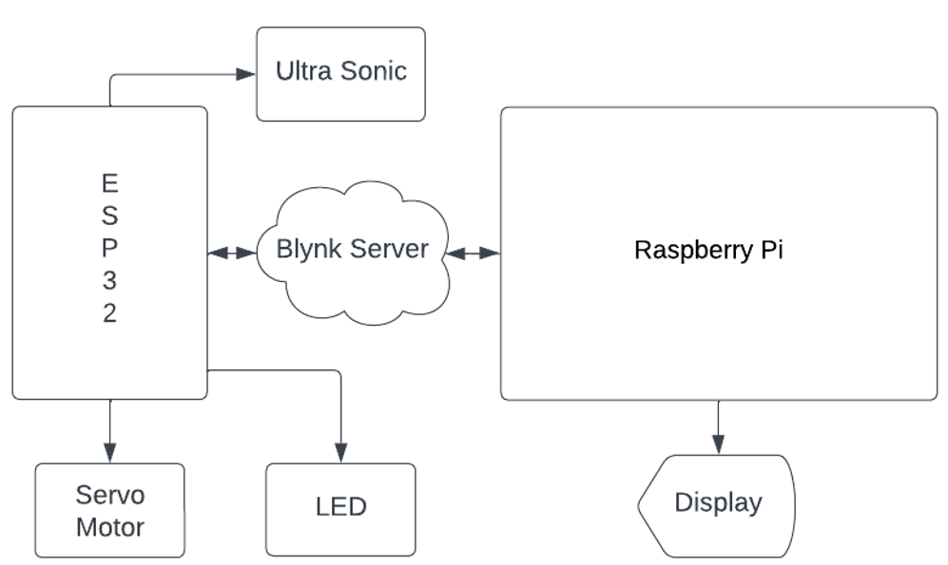Fig 1: Block Diagram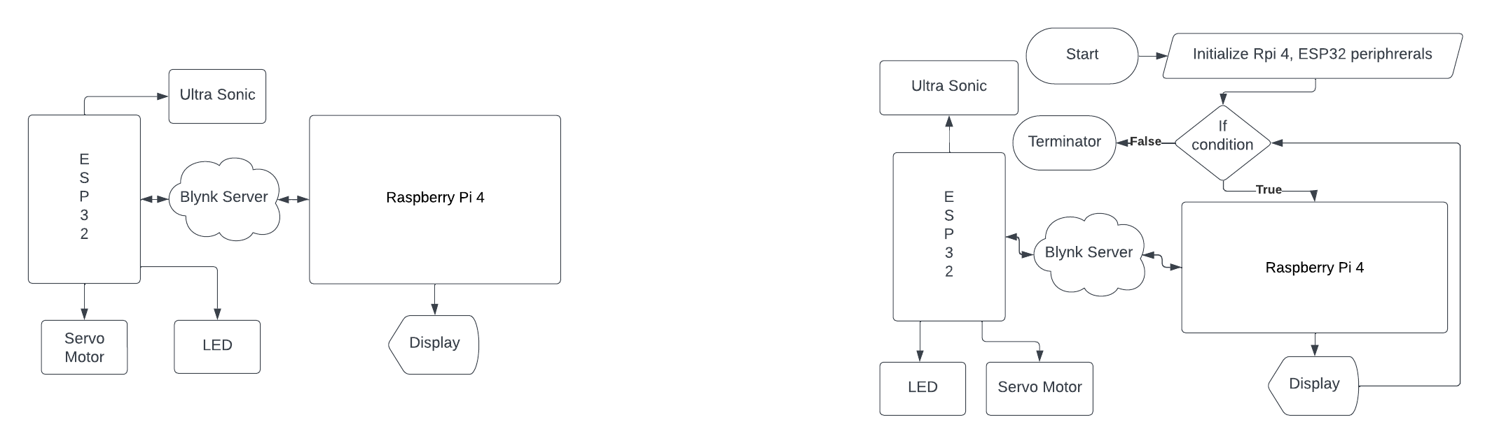Fig 2: Data Flow diagram

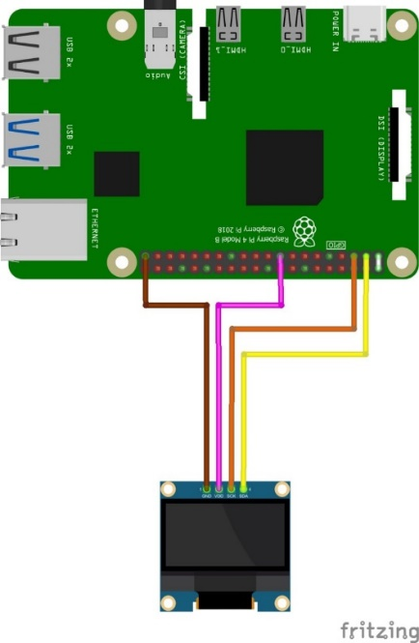

Fig 3: Master Device (Rpi) Circuit diagram

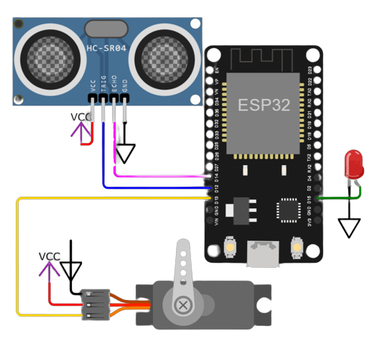Fig 4: Slave Device Esp32 Circuit diagram (Example IOT Device)

**Result**

The implementation of the centralized IoT hub using the Raspberry Pi as the master device yielded promising results. Throughout our project, we successfully integrated multiple sensors and devices into a cohesive ecosystem, allowing for efficient centralized control. Taking raspberry Pi to the next level, making raspberry Pi multipurpose use at the same time. The Raspberry Pi can enforce security policies and access controls, ensuring that only authorized devices can communicate with each IoT devices. This reduces the attack surface and minimizes the risk of unauthorized access. The output images of Master device (Raspberry Pi) and the Salce Device (IOT devices: Servo Motor, Ultra Sonic, LED) are as follows:

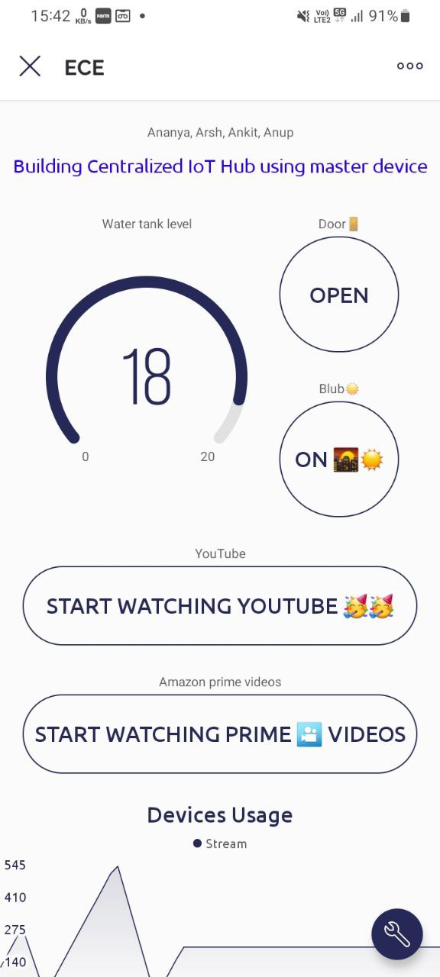

Fig 1: Water Tank level (Ultra sonic)



Fig 2: Door Open and Close Control (Servo Motor)

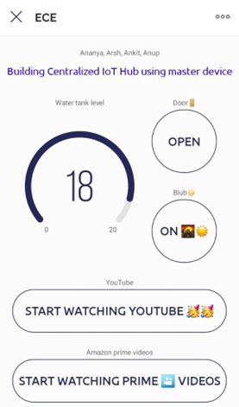

Fig 3: Blub On and Off Control (LED)

Fig 4: Watch Movies and Videos from Amazon Prime and YouTube 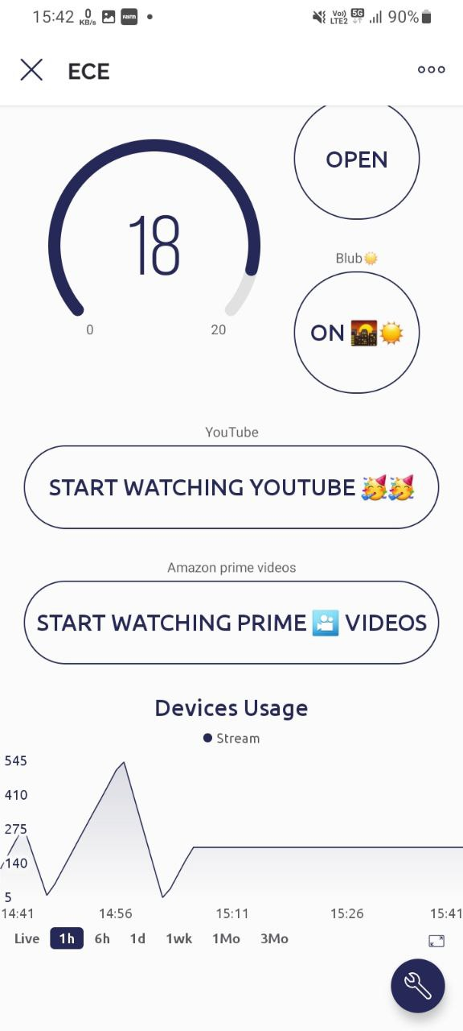Fig 5: Monitor Device usage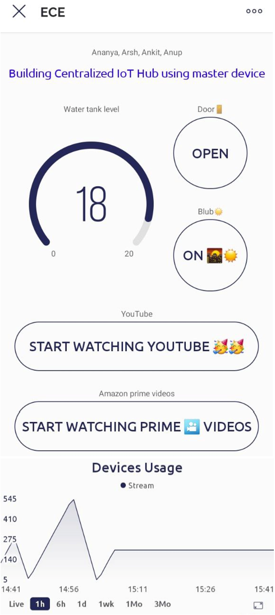

Fig 6: Blynk App controlling and showing data

**Hardware implementation Images:**

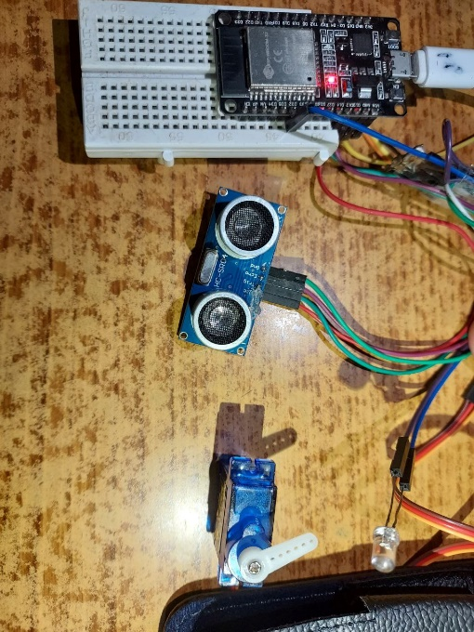Fig 7: Slave IOT devices (Servo Motor, Ultrasonic, Led

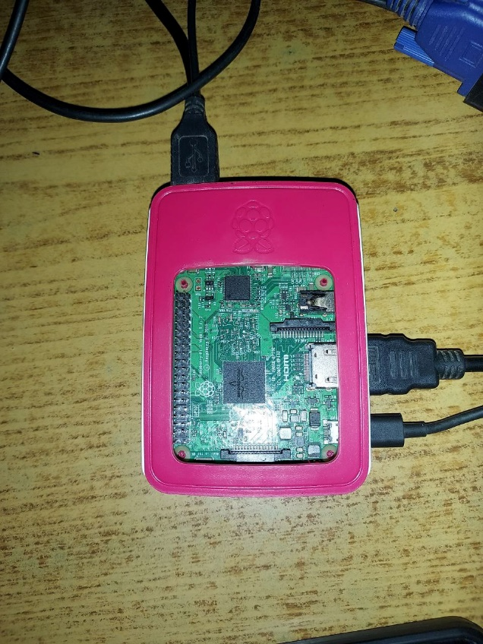Fig 8: Master Device (Raspberry Pi 3)

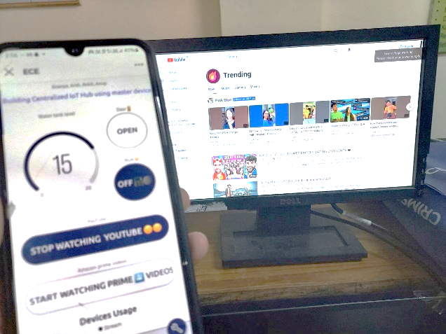Fig 9(a): Raspberry Pi used for the Entertainment (YouTube.com)

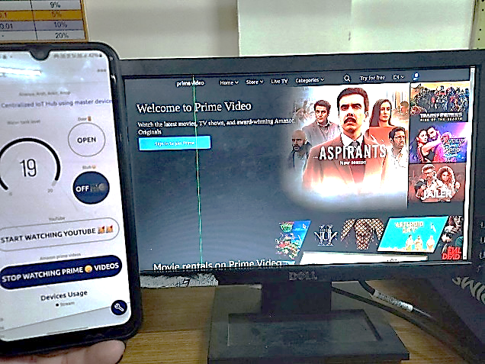Fig 9(b): Amazon prime videos

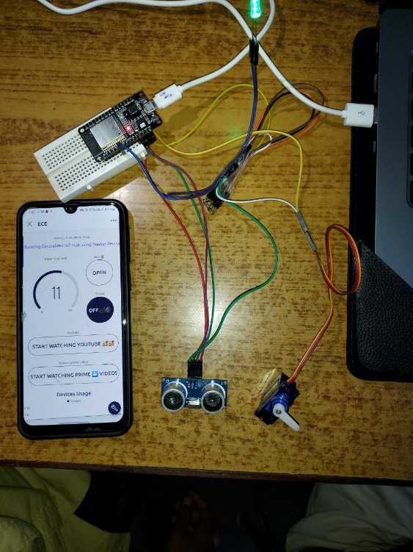

Fig 10: Controlling Slave Device (IOT) from Blynk via Master Device (Rpi)

The servo motor for door control demonstrated accuracy in both opening and closing the door in response to user commands, enhancing security and convenience. The ultrasonic sensor for water tank level monitoring provided accurate distance measurements, which were then translated into precise water level readings. This functionality was particularly valuable for ensuring water availability in a controlled manner. Adding multiple sensors to the central IoT hub's control logic, orchestrated by the Raspberry Pi, performed admirably, managing sensor data and responding promptly to user inputs through the user interface. The raspberry Pi can be also used as a personal computer or as smart device. Overall, our system exhibited reliability, scalability, and efficiency, making it a valuable addition to home automation and industrial control scenarios with addition of smart TV. These positive outcomes underscore the potential of the Raspberry Pi as a master device in shaping the future of IoT ecosystems and its capacity to provide centralized device management effectively.

**Conclusion**

In conclusion, the development of a centralized IoT hub using the Raspberry Pi as the master device represents a significant achievement in the realm of IoT technologies. Our project successfully demonstrated the capability of this hub to efficiently manage and control a variety of IoT devices, creating a seamless and interconnected ecosystem having smart TV and Personal Computer. The inclusion of sensors such as the servo motor for door control, and ultrasonic sensor for water tank level monitoring showcased the versatility and reliability of the system. The servo motor flawlessly managed door operations, enhancing security and convenience. The ultrasonic sensor accurately monitored water tank levels, providing crucial data for water management. We can use raspberry Pi for entertainment purpose, like watching movies, videos on different platform like Amazon prime videos and YouTube, many other platforms also can be added to the raspberry Pi, giving ability to users to use raspberry Pi to the next level.

The Raspberry Pi can enforce robust security policies and access controls, safeguarding the IoT ecosystem. This ensures that only authorized devices and users can interact with specific IoT devices, significantly reducing the attack surface and thwarting unauthorized access attempts. Unauthorized access is promptly detected and prevented, enhancing the overall security posture of the system. The central IoT hub, powered by the Raspberry Pi, played a pivotal role in orchestrating the entire system. It managed data from the sensors, maintained a user-friendly interface, and executed automation rules seamlessly. The system's scalability and responsiveness make it suitable for a wide range of applications, from home automation to industrial control. It has the potential to streamline daily routines, enhance efficiency, and contribute to the development of smart environments.

In essence, our research has highlighted the power and potential of the Raspberry Pi as a master device in shaping the future of IoT ecosystems. It offers a robust and extensible solution for centralized device management, representing a significant step towards a smarter, interconnected, and more efficient world. As IoT continues to evolve, our project provides valuable insights into the possibilities and benefits of centralized IoT hubs in various real-world scenarios.

**References**

*1. Perakakis, E., & Ghinea, G. (2017). Smart Enough for the Web? A Responsive Web Design Approach to Enhancing the User Web Browsing Experience on Smart TVs. IEEE Transactions on Human-Machine Systems, 47(6), 860–872.*

*2. Kuwano, H., Taniguchi, Y., Minami, K., Morimoto,M., & Kojima, H. (n.d.). A smart TV viewing and Web access interface based on video indexing techniques. 2002 Digest of Technical Papers. International Conference on Consumer Electronics.*

*3. Hahm, C.-H., Lee, S., Lee, T., & Yoo, S. (2016). Memory Access Scheduling for a Smart TV. IEEE Transactions on Circuits and Systems for Video Technology, 26(2), 399–411. doi:10.1109/tcsvt.2015.2389414.*

*4. Sang-Heon Lee, Myoung-Kyu Sohn, Dong-Ju Kim, Byungmin Kim, & Hyunduk Kim. (2013). Smart TV interaction system using face and hand gesture recognition. 2013 IEEE International Conference on Consumer Electronics (ICCE). doi:10.1109/icce.2013.648 6845*

*5. He, W., Martinez, J., Padhi, R., Zhang, L., & Ur, B. (2019). When Smart Devices Are Stupid: Negative Experiences Using Home Smart Devices. 2019 IEEE Security and Privacy Workshops (SPW). doi:10.1109/spw.2019.000 36*

*6. Sawchuk, A. A. (n.d.). Smart pixel devices and free-space digital optics applications. LEOS ’95. IEEE Lasers and Electro-Optics Society 1995 Annual Meeting. 8th Annual Meeting. Conference Proceedings. doi:10.1109/leos.199 5.484697*

*7. Junghak Kim, Seungchul Kim, Sangtaick Park, & Jinwoo Hong. (2013). Home appliances controlling through Smart TV set-top box with screen-mirroring remote controller. 2013 International Conference on ICT Convergence (ICTC). doi:10.1109/ictc.2013.6675541*

*8. Lee, S. Y., & Park, S. T. (2014). Implementation of cloud server for home screen based on smart TV. The 18th IEEE International Symposium on Consumer Electronics (ISCE 2014). doi:10.1109/isce.2014.6884295*

*9. Anufrienko, A. (2019). Appliances of Smart TV as an IoT Device for Industry 4.0. 2019 IEEE 21st Conference on Business Informatics (CBI). doi:10.1109/cbi.2019.10087*

*10. Yang, S.-H., Liu, X.-W., & Lo, Y.-C. (2016). A design framework for smart TV: Case study of the TaipeiTech smart TV system. 2016 IEEE International Conference on Consumer Electronics-Taiwan (ICCE-TW). doi:10.1109/icce-tw.2016.7521053*

*11.* *Alam, I., Khusro, S., & Naeem, M. (2017). A review of smart TV: Past, present, and future. 2017 International Conference on Open Source Systems & Technologies (ICOSST). doi:10.1109/icosst.2017.8279002*

*12.* *Sang Yun Lee, & Sang Taick Park. (2013). Design and implementation of basic smart TV functions on the web browser. 2013 International Conference on ICT Convergence (ICTC). doi:10.1109/ictc.2013.6675530*

*13.* *Perakakis, E., Ghinea, G., & Thanou, E. (2015). Are websites optimized for mobile devices and Smart TVs? 2015 8th International Conference on Human System Interaction (HSI). doi:10.1109/hsi.2015.7170642*